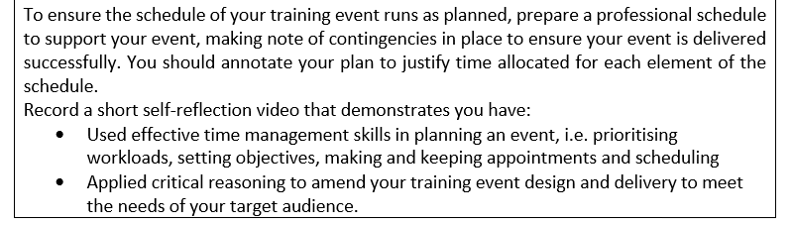

Effective Time Management Skills

Splitting each planning task into a title, working out what to do based on that

Objective outlining by brainstorming ideas

Target audience

Census data around the industry to identify common demographics

Identified proportion of gender in the census data and identified the potential glass ceiling issue and that life experience and understanding between the group is best distributed equally.

Age and gender diversity within each group helps with experience and understanding.

Identified a potential catchup scenario due to basic knowledge of the training topic being unreliable, so a refresher is an important component.

Part 1

By splitting the planning section into subtitles and focussing on one at a time, it allowed for development of each element individually as well as the ability to go into depth on each individual topic. This was a good method for producing this plan as it allowed me to work out exactly when to plan on each subtitle, and allowed for compartmentalisation and focus, which sped up my workflow considerably.

I also listed a set of objectives by brainstorming the potential for learning, representing ideal outcomes for the training event. These four objectives fit into the style of delivery as well, as there’s an introduction to cover the smallest objective (likely the result of cyber security problems objective), then using the three training stations to cover the other larger objectives.

The general idea around using different groups for training is that it introduces a competitive side to learning, and allows for individual interaction, as stated in the plan. I like this method as it works well with the team system I came up with, allowing for splitting the group based on demographics. There are other possible solutions to this that scale better with group size, such as more groups, however that would require more time for delivery.

Part 2

I identified data based on a 2014 US census around the IT industry stating some basic facts about the general demographics of the industry, and used that information as a way to divide up the groups for the training segments. By integrating the different demographics into each group, I hope that experience and understanding will be the most equal between the three, with more varied viewpoints in each group. Of course, demographics aren’t a perfect way to identify understanding and intelligence, however it’s the best information I have, and generalisations in this context are generally positive, I feel.

As well as integrating potentially different levels of experience and understanding, I hope that by mixing age groups in particular, the groups will work together in a catch-up kind of way, with the more understanding members (whether younger or older) helping the less understanding members, teaching each other as well as being taught.